ASSIGNMENT – 7.3
VIDHU SREE DAYYALA
2303A52400
Batch – 41

Task 1: Fixing Syntax Errors
Prompt:
Detect and fix the syntax error in the given Python function. Explain what was wrong and how it was corrected.

Scenario:
You are reviewing a Python program where a basic function definition contains a syntax error.
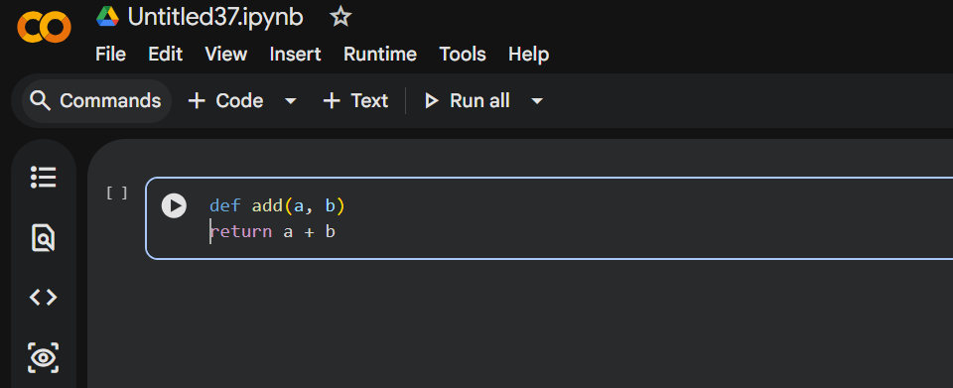

Error: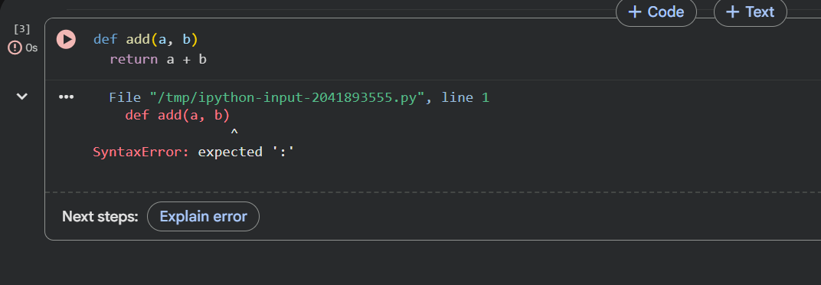

Error Explanation:
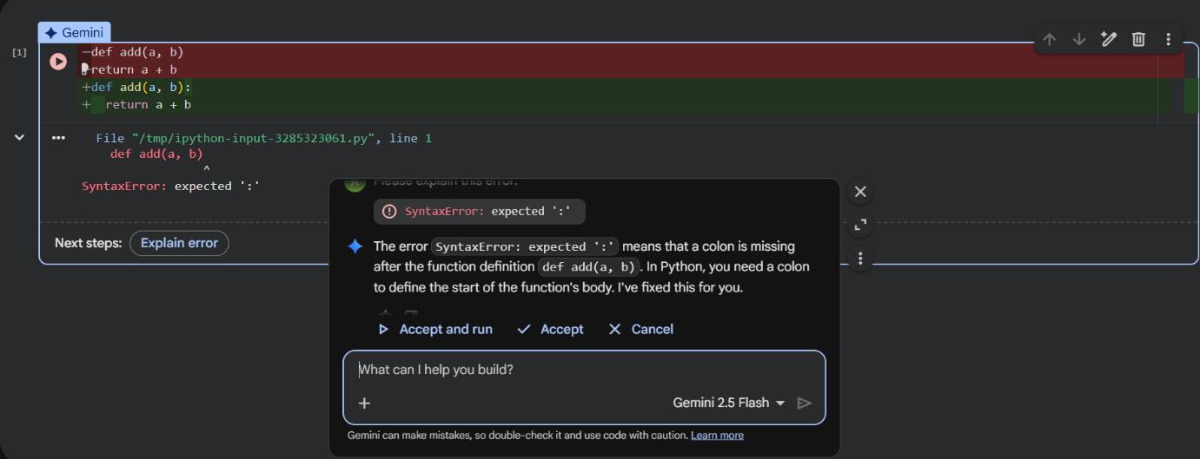

AI Corrected Code/Output:
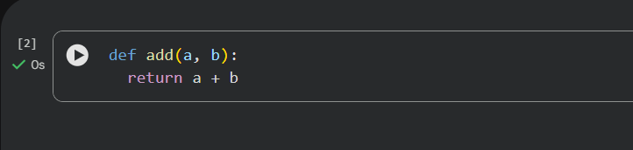

Justification:
The syntax error occurred because Python requires a colon (:) at the end of a function definition. The AI correctly identified the missing colon and fixed it, allowing the function to compile and run without errors.

Task 2: Debugging Logic Errors in Loops

Scenario:
You are debugging a loop that runs infinitely due to a logical mistake

Prompt:
Identify why this loop runs infinitely and fix the logical error. Explain the correction.

Error: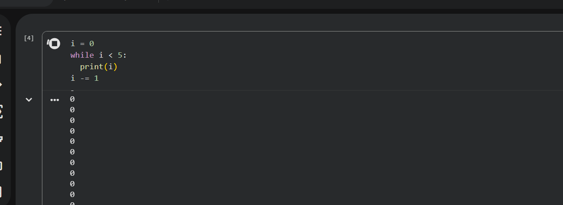

Error Explanation:
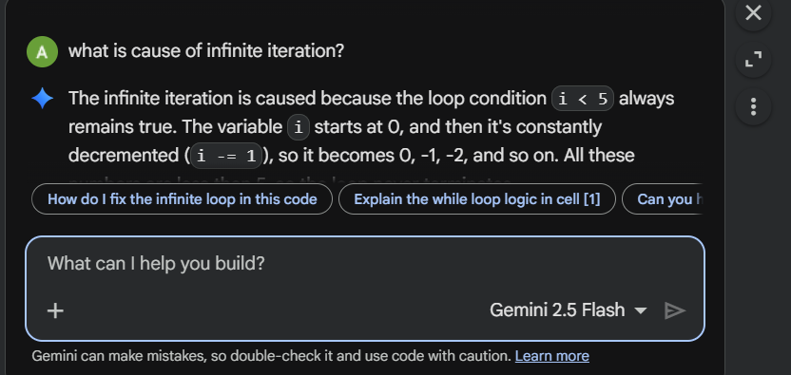

AI Corrected Code/Output:
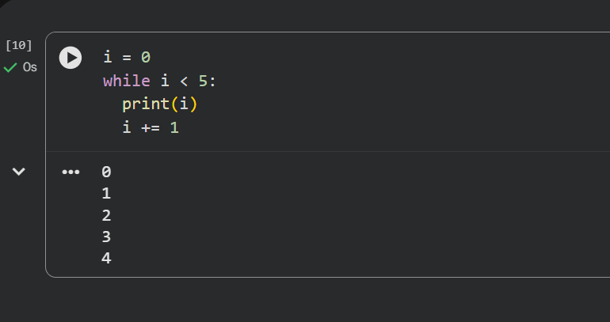

Justification:
The loop was infinite because the variable i was decremented instead of incremented, so the condition i < 5 always remained true. The AI fixed the logic by incrementing i, ensuring the loop terminates correctly.

Task 3: Handling Runtime Errors (Division by Zero)
Scenario:
You are debugging a loop that runs infinitely due to a logical mistake.
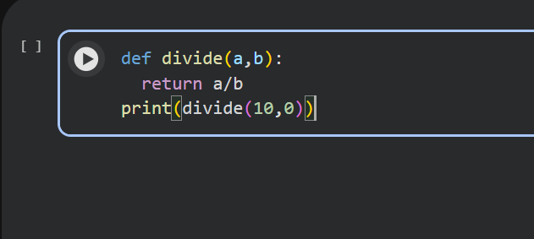
Prompt:
Detect the runtime error in this function and modify the code to handle it safely using exception handling.

Error:
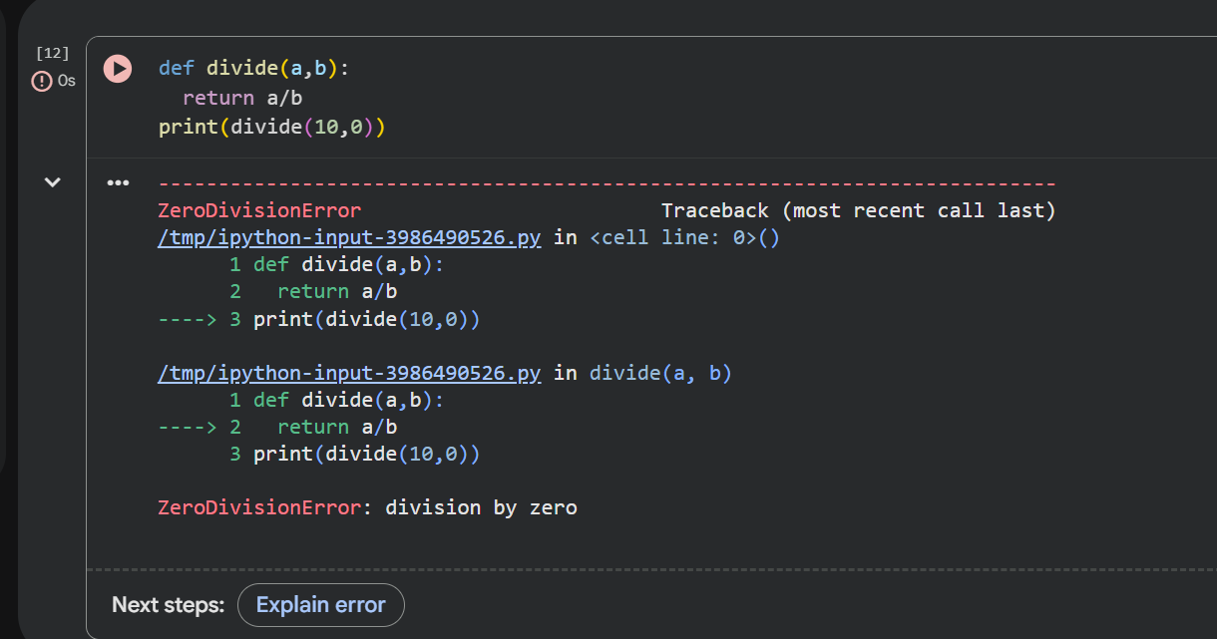

Error Explanation:
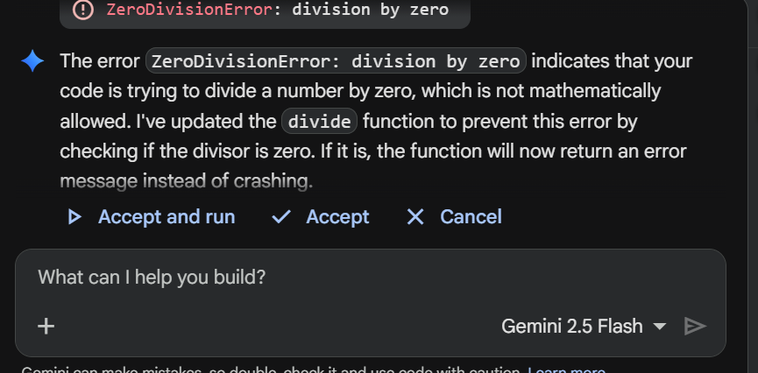

AI Corrected Code/Output:
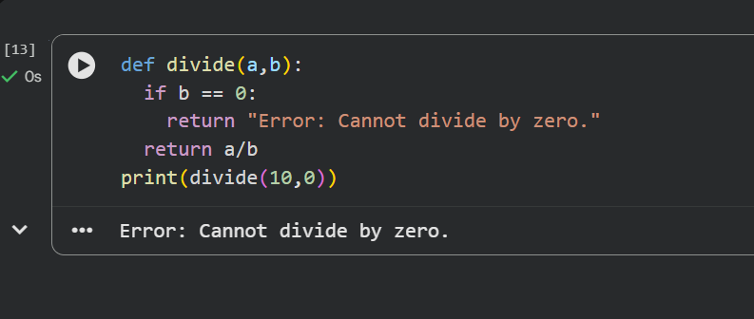

Justification:
The function crashed when b was zero, causing a runtime error. The AI added a try-except block to catch ZeroDivisionError, allowing the program to handle the error gracefully without crashing.

Task 4: Debugging Class Definition Errors
Scenario:
You are given a faulty Python class where the constructor is incorrectly defined.
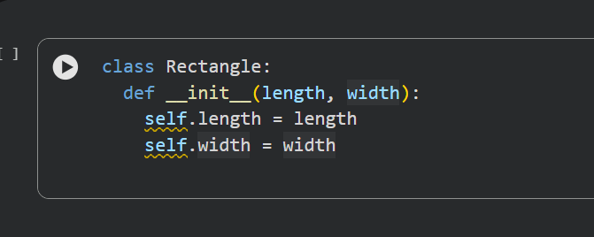

Prompt:
Find the error in the class constructor and correct it. Explain why the fix is required.

Error:
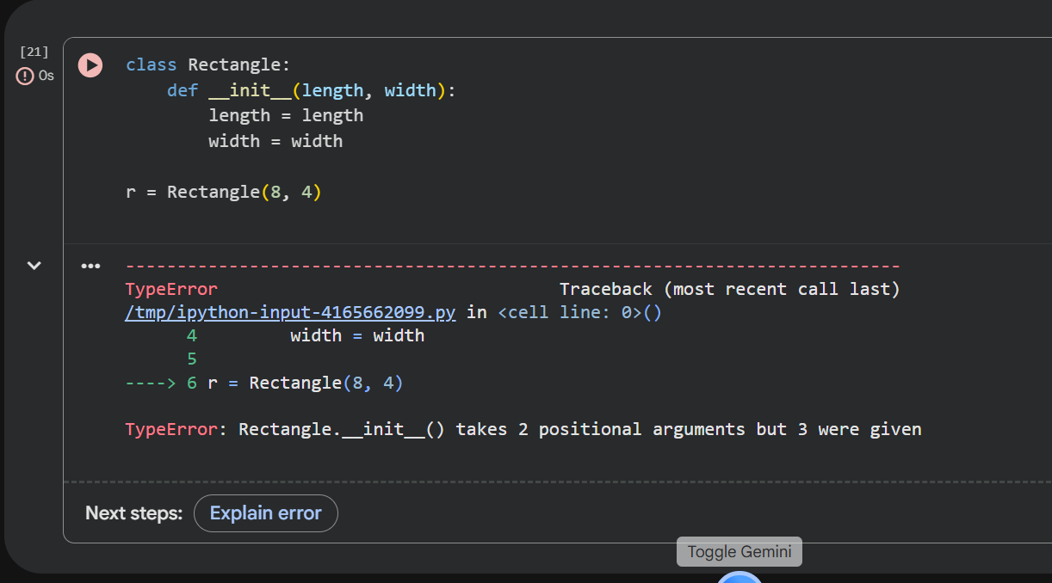

Error Explanation:
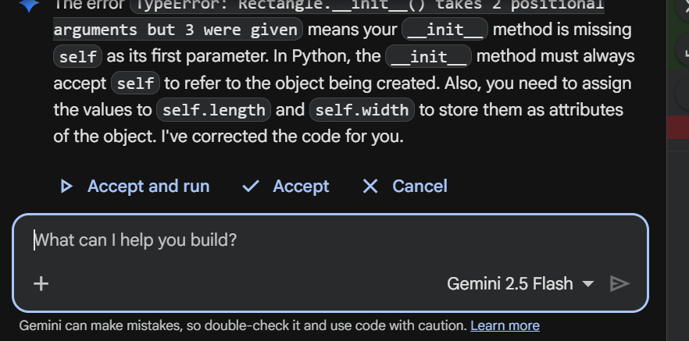

AI Corrected Code/Output:
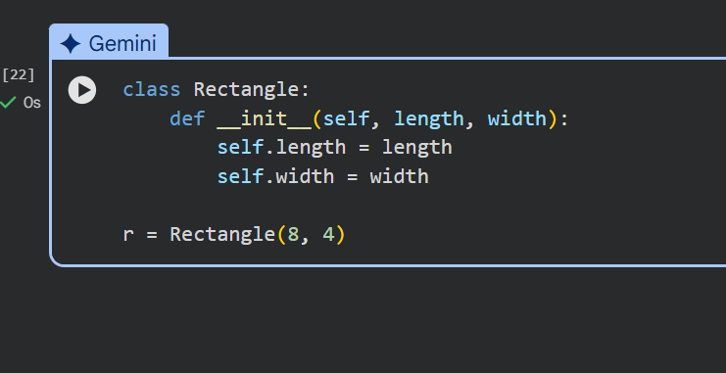

Justification:
The constructor was missing the self parameter, which is required to refer to the current object in Python. The AI corrected the method signature and properly assigned instance variables using self.

Task 5: Resolving Index Errors in Lists
Scenario:
A program crashes when accessing an invalid index in a list.
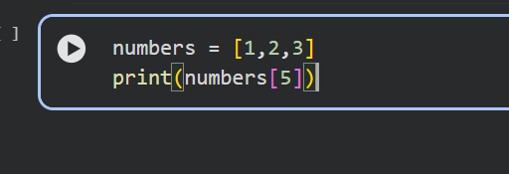

Prompt:
Identify the index error in the list access and apply a safe solution. Explain the fix.

Error:
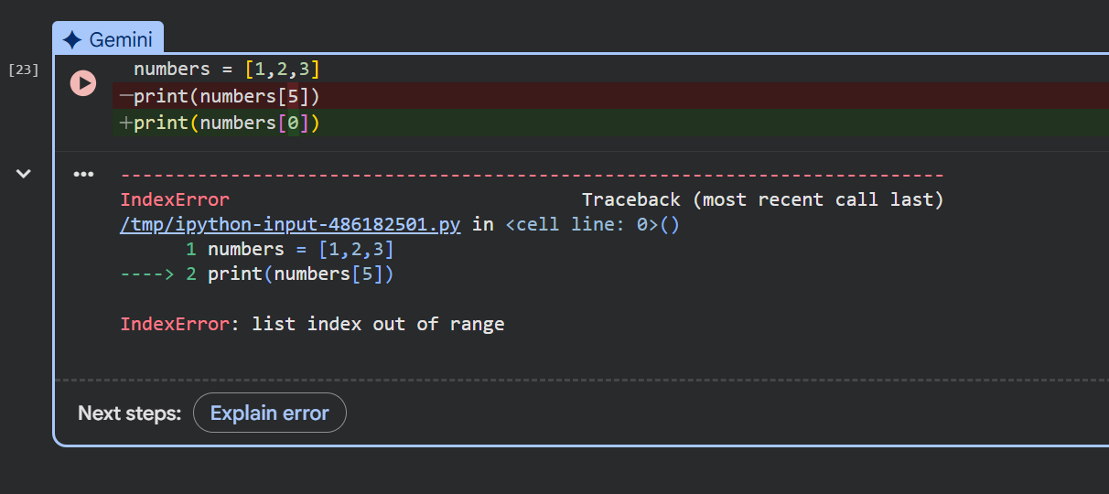

Error Explanation:
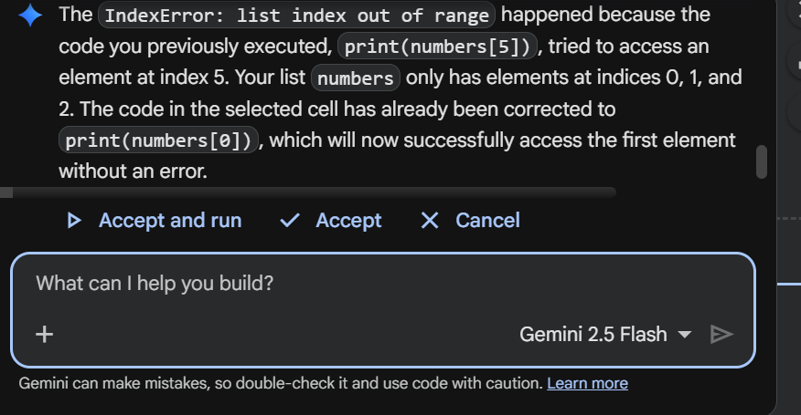

AI Corrected Code/Output:
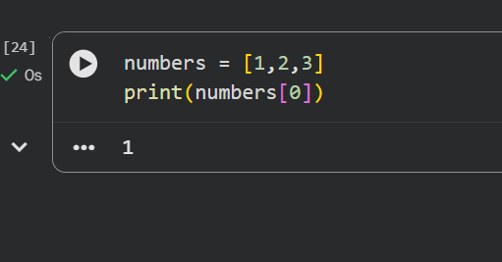

Justification:
The program attempted to access an index that does not exist in the list, causing an IndexError. The AI suggested checking the index against the list length before accessing it, preventing the runtime crash.

